TEMPLATE WEBSITE/BLOG ARTICLE FOR WORLD PI WEEK
----

Join the World PI Week 2019 “Putting primary immunodeficiency patients at the centre of their care”!

On the last week of April (22-29 April), people from around the world celebrate the World PI Week campaign, to raise awareness and understanding of primary immunodeficiency. The ultimate goal is to bring about change in policy and healthcare practice and improve the care and quality of life of patients and their families.
This year, patient-centred care is at the heart of the campaign!
There are over 320 different types of primary immunodeficiencies which are estimated to affect over 6 million people worldwide. In [add your country], nearly [add number of people with PI] are living with these rare diseases.
People with primary immunodeficiency are all different: their specific health needs should be taken into consideration in their care pathway; and treatments be personalised to their situation.
In patient-centred care, healthcare systems are designed to ultimately benefit patients. The systematic implementation of new-born screening for severe forms of primary immunodeficiency is one example of this, by ensuring that patients can be diagnosed at an early stage.
Beyond, patient-centred care allows for patients and their families to be partners of healthcare providers in the decisions related to their own care and treatment plans.
During the World PI Week, [Insert your organisation’s name] will [add details of your organisations’ plans/activities for World PI Week]. We hope you will join us!
Learn more about how to engage and participate in the World PI Week here. You will find materials, resources and ideas to help you raise awareness around you and take part in the efforts of the primary immunodeficiency community globally!
More information: www.worldpiweek.org or email info@worldpiweek.org

Suggestions of accompanying pictures:
- World PI Week 2019 poster (translations here)
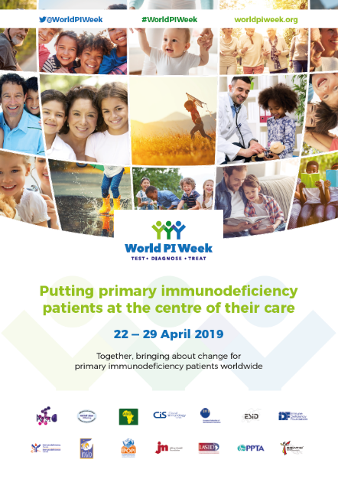

- World PI Week flyer
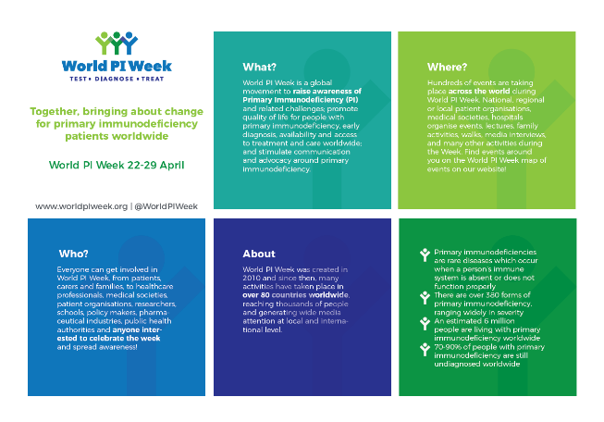

- World PI Week 2019 e-banner
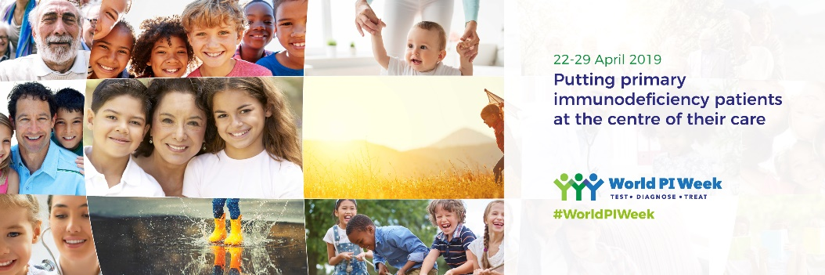

The 2017 IUIS Phenotypic Classification for Primary Immunodeficiencies

