TEMPLATE WEBSITE/BLOG ARTICLE FOR WORLD PI WEEK 2020
----

Join the World PI Week 2020: 10 years - Celebrating life and what keeps the primary immunodeficiency community moving forward!
10 weeks of campaigning for the 10th anniversary

From the 22nd April to the 1st of July 2020, people from around the world will celebrate the World PI Week campaign, to raise awareness and understanding of primary immunodeficiency. The ultimate goal is to bring about change in policy and healthcare practice and improve the care and quality of life of patients and their families.
This year, World PI Week celebrates its 10th anniversary. 10 years of collaboration and awareness raising across the globe. The 2020 campaign is therefore all about celebrations.
There are over 320 different types of primary immunodeficiencies which are estimated to affect over 6 million people worldwide. In [add your country], nearly [add number of people with PI] are living with these rare diseases.
We are celebrating the efforts undertaken worldwide by patients and patient organisations, families, physicians, nurses and other healthcare professionals, policymakers, industry, schools and many other actors to improve outcomes for people living with the disease.
Furthermore, the #WPIW10years campaign celebrates the aspirations of a community that, together, thrives for greater awareness of primary immunodeficiencies, early diagnosis, availability and access to treatment and care worldwide, resulting in better quality of life. This includes expectations on universal access to life-saving treatments, patient-centered policy making, a sustainable, high-quality supply of human plasma and increased worldwide plasma collection, to name a few.
During the World PI Week, [Insert your organisation’s name] will [add details of your organisations’ plans/activities for World PI Week]. We hope you will join us!
Learn more about how to engage and participate in the World PI Week here. In light of the COVID-19 pandemic, many resources are provided for virtual engagement. You will find materials and ideas to help you raise awareness and take part in the efforts of the primary immunodeficiency community globally!
More information: www.worldpiweek.org or email info@worldpiweek.org
Together, bringing about change for primary immunodeficiency patients worldwide!
Suggestions of accompanying pictures:
- World PI Week 2020 poster (translations here)
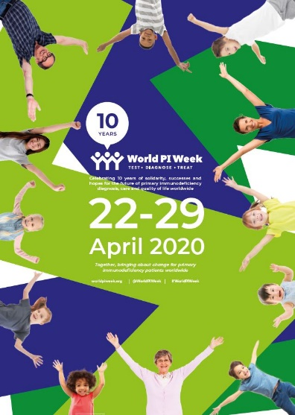

- World PI Week flyer
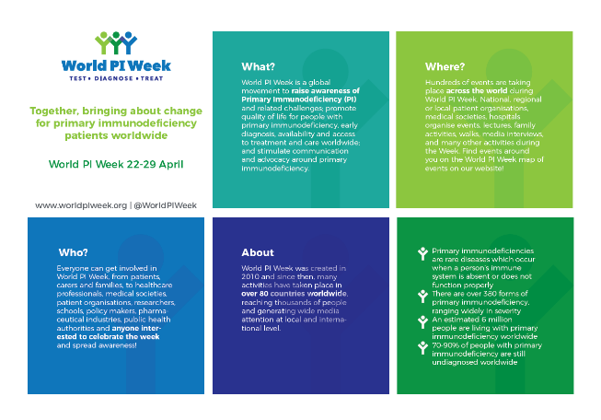

- World PI Week 2020 e-banner
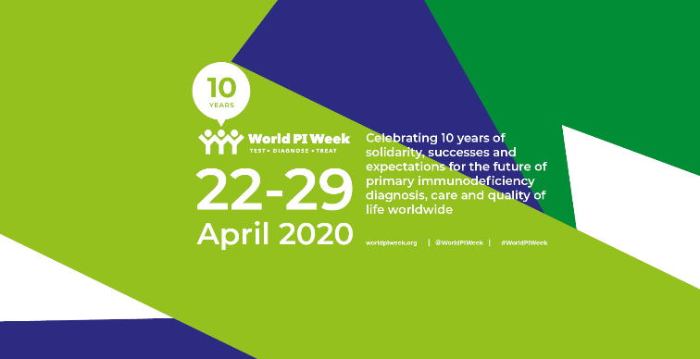

The 2017 IUIS Phenotypic Classification for Primary Immunodeficiencies

